Appendix: Blended Learning Guidance Tools
Tools | Double-click to open the file | Or click to download
Educator Role Diagnostic  This tool asks a series of questions to help schools define the roles that educators will need to play. | 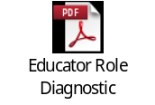 | Download>
Goals and Considerations  Establishing what your blended learning model is intended to accomplish and evaluating considerations that will impact your ability to implement it will help you choose the most appropriate model for your district or school. | 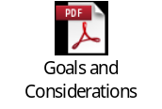 | Download>
Sample 360⁰ Review Questions  Student surveys may be modified to give evaluators a view into the student experience to understand their feelings toward the blended learning model and the teacher’s role. Here are some blended-learning-specific questions to consider adding. | 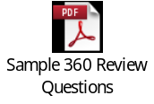 | Download>
Sample Interview Questions  In these sample teacher candidate interview questions, we focus each question on one or more of the core competencies critical to success for blended learning teachers. | 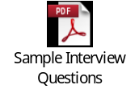 | Download>
Talent Assessment  This talent assessment is designed to help you determine your talent needs at the classroom level, who among your staff could fill available roles, their skills and how they align with your talent needs, necessary external recruitment, and gaps to address in professional development. | 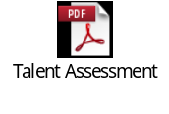 | Download>
TNTP Core Teaching Rubric for Blended Learning  This teacher observation rubric modifies TNTP’s Core Rubric for blended learning considerations. Use this rubric or use as a guide to modify the rubric used in your school. | 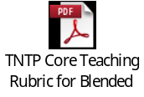 | Download>

